Dashboard Design

Date | 19 September 2026
Team ID | MCA
Project Name | Online Learning Engagement and Student Performance Analysis
Maximum Marks | 5 Marks

The Online Education Analytics Dashboard presents student performance, engagement, and dropout-related insights in an interactive visual format. The dashboard uses KPI cards, charts, a donut chart, and slicers to help users understand student outcomes and compare performance across different dimensions.
Activity 1: Interactive and visually appealing dashboards
Creating a good and interactive dashboard needs simple design, clear visuals, and useful features. The following points will help you make a dashboard that is easy to use, understand, and explore.

- Clear and Intuitive Layout: The dashboard has a clear hierarchy with a title section, KPI cards at the top, visual analysis sections in the centre, and filter controls on the right.
- Use Appropriate Visualizations: Bar charts are used for regional student counts, average clicks by engagement level, average score by engagement level, and average score by performance level. Donut charts show student distribution by final result and performance level.
- Colour and Theming: A consistent blue-themed visual style is used for the dashboard header, KPI labels, charts, and other visual elements, supporting a consistent presentation.
- Interactive Filters and Slicers: The dashboard provides slicers for gender, region, engagement level, performance level, risk level, and final result so users can filter the analysis.
- Drill-Down Capabilities: The visual structure is suitable for further drill-down analysis by student attributes such as region, engagement level, performance level, and final result where supported by the Power BI model.
- Responsive Design: The dashboard arranges KPI cards, charts, and slicers in clearly separated sections to support an organized viewing experience.
- Custom Visuals and Icons: KPI cards and donut/bar visualizations are used to present important metrics and categorical comparisons in a compact form.
- Use of Infographics: The KPI section acts as an infographic-style summary of the main measures: total students, average clicks, dropout rate, pass rate, and average score.
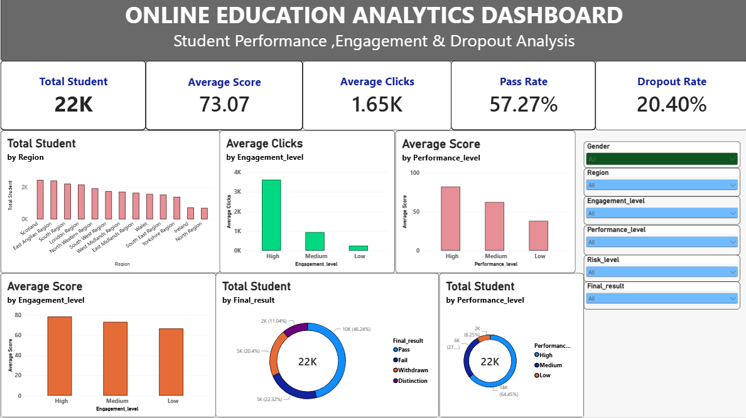
Here are five potential outcomes from the dashboard image provided:
- 1. Total Student Count: The dashboard reports approximately 22K students, providing an overall view of the size of the online education dataset.
- Engagement: Average clicks are approximately 1.65K. The engagement-level chart shows substantially higher average clicks for High engagement than Medium and Low engagement.
- Student Outcomes: The final-result donut chart shows Pass as the largest category, followed by Fail, Withdrawn, and Distinction.
- Performance: The performance-level analysis shows that students in the High performance category have the highest average score, followed by Medium and Low performance.
- Key Performance Indicators: The dashboard reports a 20.40% dropout rate, a 57.27% pass rate, and an average score of 73.07, providing a concise summary of student performance and retention.

